**BỘ GIÁO DỤC VÀ ĐÀO TẠO**

**TRƯỜNG….**

**-------oOo-------**

**BÁO CÁO TỔNG KẾT ĐỀ TÀI**

**TÊN ĐỀ TÀI: CẢI TIẾN XE LĂN THƯỜNG THÀNH XE LĂN ĐIỆN THÔNG MINH**

**Chủ nhiệm đề tài:**

**Giảng viên hướng dẫn:**

*TP.* *Hồ Chí Minh, tháng năm 20*

TABLE OF CONTENTS

Chapter I. Overall 3

1.1 Urgency of the subject 3

1.2 Practical applications 3

Chapter II. Content 4

2.1 Overview 4

2.1.1. PlayStation Controller mode: 4

2.1.2. Line following mode: 4

*2.2.* List of devies 5

2.3. Wheelchair Control System Using the Wireless PlayStation 2 (PS2) Controller 8

*2.4.* Obstacle Detection and Deep Drop Detection System. 10

*2.5.* Fall detection alert system. 11

CONCLUSION 14

REFERENCE 15

ARTICLE 16

LIST OF FIGURES AND TABLES

Table 1. List of devices and their functions. 5

Table 2. Danh mục các chân được sử dụng và chức năng 6

Chapter I. Overall

* 1. Urgency of the subject

Safety has long been a prevalent issue related to wheelchair use, with one study highlighting that 55% of wheelchair users reported experiencing at least one collision, and 17% reported experiencing two or more collisions within a three year period. Elderly users are particularly prone to accidents, often due to rapid descents, blind spots, or deep holes,which cause loss of balance and falls. Another serious issue is elderly individuals living alone, unable to get timely assistance when a fall occurs.

Therefore, technological advancements have enabled the creation of smarter, more convenient electric wheelchairs, enhancing mobility and independence for users. However, many of these expensive models lack features like obstacle detection, fall alerts, line-following, and emergency activation. Given the large number of traditional wheelchairs, upgrading them into electric ones would be a necessary and practical solution.

The development of affordable programmable devices and electronic components makes it feasible to upgrade traditional wheelchairs into electric ones with smart features, greatly benefiting users, especially elderly individuals in difficult circumstances. In this project, a passionate student in science, technology, and programming sought guidance from teachers and online resources to enhance their skills and self-learning ability. Through this project, the author aims to contribute to the community by improving the quality of life for elderly and isolated individuals.

* 1. Practical applications

Electric wheelchairs have diverse applications and significantly impact various aspects of life, such as:

* **Personal Mobility:** They provide flexible personal mobility for individuals with disabilities or health limitations, enabling them to move easily in public spaces like supermarkets, parks, or residential areas without needing assistance.
* **Healthcare:** Electric wheelchairs play a crucial role in delivering medical and healthcare services to individuals with mobility challenges. They are used in hospitals, clinics, and long-term care facilities to support patient movement and transportation.
* **Recreation and Leisure:** Electric wheelchairs allow individuals with mobility impairments to participate in recreational and leisure activities. They enable users to visit parks, attend social events, explore outdoor environments, and engage in hobbies and sports. This enhances their quality of life, promotes social inclusion, and supports mental and physical well-being.

Chapter II. Content

* 1. Overview

In this study, the author applies programmable microcontrollers, sensors, and actuators to upgrade a standard wheelchair into an electric wheelchair with the following key functions:

* + 1. PlayStation Controller mode:
* The programming allows the wheelchair to move and adjust its speed based on a wireless PS2 handheld controller.
* While the wheelchair is moving, it can detect obstacles ahead and issue warnings, even automatically stopping if the user persists in steering the wheelchair towards the obstacle.
* During movement, the system can detect deep drops, such as staircases, and will activate a halt to prevent the wheelchair from moving further, avoiding a potential fall.
* In the event of a fall, vibration and tilt sensors will detect the incident, sound an alarm, and send an emergency call signal to the caregiver's phone.
  + 1. Line following mode:
* The programming enables the wheelchair to move autonomously by following pre-existing lines, allowing the operator to avoid manual control during movement.
* The wheelchair speed can be easily adjusted using speed-up or speed-down buttons.
* While the wheelchair is moving, it can detect obstacles ahead and issue warnings, even automatically stopping if the user persists in steering the wheelchair toward the obstacle.
* During movement, the system can detect deep drops, such as staircases, and will trigger the wheelchair to stop, preventing further movement and avoiding potential falls.
* In the event of a fall, vibration and tilt sensors will detect the incident, sound an alarm, and send an emergency call signal to the caregiver's phone.

## List of devies

Table 1. List of devices and their functions.

|  |  |  |  |
| --- | --- | --- | --- |
| TT | Devices | Function | Image |
| 1 | Arduino Mega | Used to connect with sensors and read signals from them, providing corresponding outputs. |  |
| 2 | Motor (x2) | Run the wheelchair |  |
| 3 | Ultrasonic Sensor  (x) | Measure the distance |  |
| 4 | Driver | Used to control the direction and speed of the wheelchair according to the user's preferences. |  |
| 5 | Vibration Sensor SW1801P | Used to collect vibration level signals. |  |
| 6 | Gyro Sensor MPU9250 | Used to measure the tilt angle of the wheelchair. |  |
| 7 | Sim 4g | Used to send messages. |  |

Table 2. Danh mục các chân được sử dụng và chức năng

| TT | ĐỊA CHỈ | TÊN | CHỨC NĂNG CỦA CHÂN |
| --- | --- | --- | --- |
| 1 | A0 | enaA | Generates pulses for the left motor |
| 2 | A1 | enaB | Generates pulses for the right motor |
| 3 | 9 | out1 | Controls the left motor |
| 4 | 8 | out2 | Controls the left motor |
| 5 | 7 | out3 | Controls the right motor |
| 6 | 6 | out4 | Controls the right motor |
| 7 | 13 | PS2_DAT | Reads data signals from the PS2 controller |
| 8 | 12 | PS2_CLK | Reads clock signals from the PS2 controller |
| 9 | 11 | PS2_SEL | Read select signals from the PS2 controller |
| 10 | 10 | PS2_CMD | Reads command signals from the PS2 controller |
| 11 | A3 | vibrationSensor | Reads signals from the vibration sensor |
| 12 | 14 | RS |  |
| 13 | 4 | buzzer | Controls the horn |
| 14 | 15 | E |  |
| 15 | SDA / 20 |  | Reads signals from the tilt sensor |
| 16 | SCL / 21 |  | Reads signals from the tilt sensor |
| 17 | 22 | trigUs1 | Reads signals from the ultrasonic sensor |
| 18 | 24 | echoUs1 | Reads signals from the ultrasonic sensor |
| 19 | 26 | trigUs2 | Reads signals from the ultrasonic sensor |
| 20 | 28 | echoUs2 | Reads signals from the ultrasonic sensor |
| 21 | 30 | trigUs3 | Reads signals from the ultrasonic sensor |
| 22 | 32 | echoUs3 | Reads signals from the ultrasonic sensor |
| 23 | 34 | trigUs4 | Reads signals from the ultrasonic sensor |
| 24 | 36 | echoUs4 | Reads signals from the ultrasonic sensor |
| 25 | 38 | trigUs5 | Reads signals from the ultrasonic sensor |
| 26 | 40 | echoUs5 | Reads signals from the ultrasonic sensor |
| 27 | 16 | D4 |  |
| 28 | 17 | D5 |  |
| 29 | 18 | D6 |  |
| 30 | 19 | D7 |  |

## Wheelchair Control System Using the Wireless PlayStation 2 (PS2) Controller

This section presents the operational principle of the wheelchair controlled by the PS2 joystick. The wheelchair can move forward or backward and adjust its speed based on the two joysticks of the PS2 controller. The wiring diagram of the devices is illustrated in the following figure.

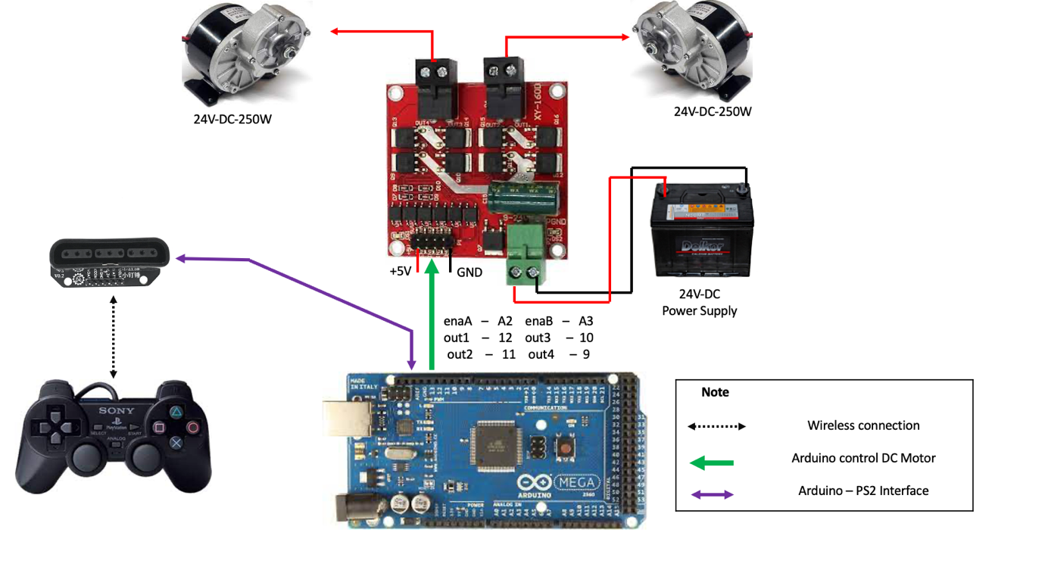

Graphic 1. Wiring Diagram of the Microcontroller with the Wireless PS2 Controller

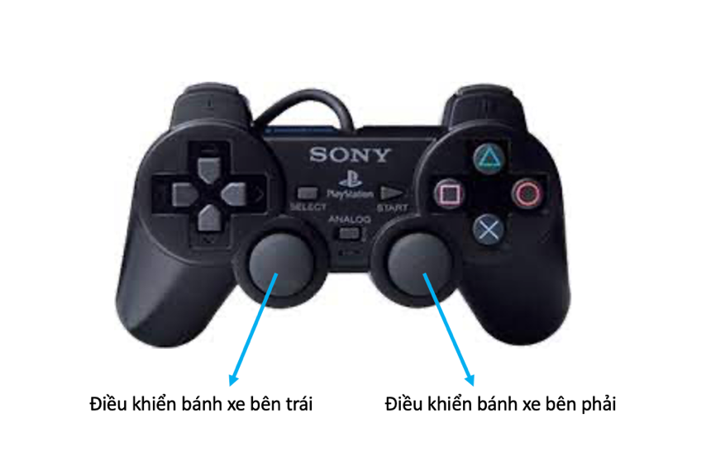

Graphi 2. Control button

* When the user wants the wheelchair to move straight, they push both the left and right joysticks forward. The following code segment handles the functionality that allows the wheelchair to move straight

if ( leftStickY <= 127 ) {

forwardMotor1();

speedMotorA = map(abs(127-leftStickY), 0, 127, 0, 170);

}

* Ngược lại, khi người dùng muốn xe đi lùi thì đẩy cả hai joystick trái và phải cùng về phía sau.

if ( leftStickY >= 127 ) {

backwardMotor1();

speedMotorA = map(abs(127-leftStickY), 0, 127, 0, 170);

}

* Conversely, when the user wants the wheelchair to move backward, they push both the left and right joysticks backward. The following code segment manages the functionality that allows the wheelchair to move in reverse:

if ( rightStickY <= 127) {

forwardMotor2();

speedMotorB = map(abs(127-rightStickY), 0, 127, 0, 170);

}

* Similarly, for turning right, when the user wants the wheelchair to turn right, they push the right joystick backward while pushing the left joystick forward, or they can simply push the left joystick forward while keeping the right joystick stationary. The following code segment handles the functionality for turning right:

if ( rightStickY >= 127 ) {

backwardMotor2();

speedMotorB = map(abs(127-rightStickY), 0, 127, 0, 170);

}

* The speed of the wheelchair will depend on the distance from the joystick's neutral position (the center). The further the joystick is pushed away from the neutral position, the faster the wheelchair will move.

## Obstacle Detection and Deep Drop Detection System.

In this section, the author develops a system that enables monitoring and provides alerts when obstacles are detected ahead or when deep drops are identified. In the case of obstacle detection, if the operator continues to command forward movement, the system will remain inactive and will issue a warning or prompt the user to navigate in a direction without obstacles. Additionally, if the wheelchair approaches an area with a drop, the system will alert the user and activate the brakes to prevent the wheelchair from falling into the drop.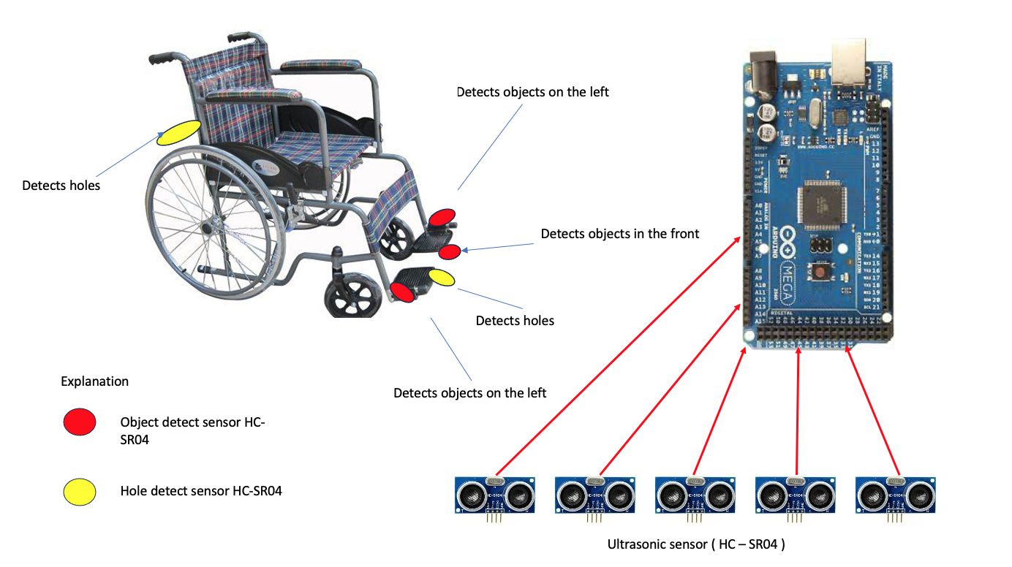 Graphic 3. Position

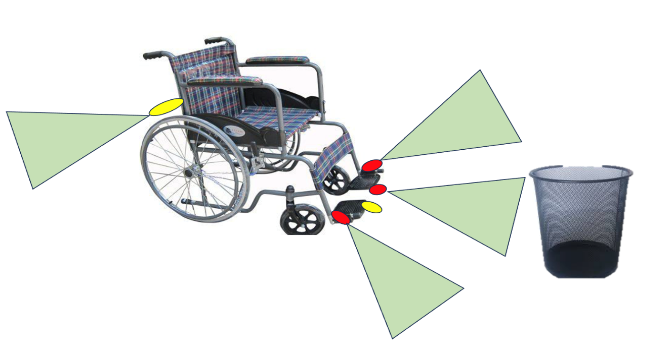

Graphic 4. Range of sensor

* Operating Principle of Obstacle Detection Sensor:

When the vehicle is in motion and detects an obstacle in front, if the distance from the sensor to the object is less than 2 meters (< 2m), the vehicle will decelerate. If there are no obstacles on the left or right sides, the vehicle will alert the operator. In cases where the operator continues to hold the control button and the vehicle moves forward despite the warning, if the distance becomes less than 1 meter (< 1m), the vehicle will automatically stop.

* Operating Principle of Deep Hole Detection Sensor:

When the vehicle is in motion and detects a hole ahead, it will issue a warning and come to a stop. At this point, any attempts to continue forward control will be ineffective. This principle also applies to the hole detection sensor located at the rear of the vehicle.

## Fall detection alert system.

In this section, the author has developed a data collection system aimed at detecting when a wheelchair is tilted or when a user has fallen. In such cases, the system will automatically sound an alarm and send a message to the caregiver or family members of the user. By integrating sensors with a microcontroller, the system is capable of rapidly and autonomously responding to hazardous situations, thereby enhancing the safety of the user.

To implement this functionality, the author employs a vibration sensor (SW1801P) in conjunction with an inclination sensor (MPU9250). In the event of a fall, the inclination sensor will detect the angle of tilt of the y-axis, which has been pre-defined, while the vibration sensor will send a signal. These two signals will be used to trigger an alarm on the wheelchair and to send a message via a SIM module to the emergency contact's phone number. The wiring diagram for the devices is presented in the following figure.

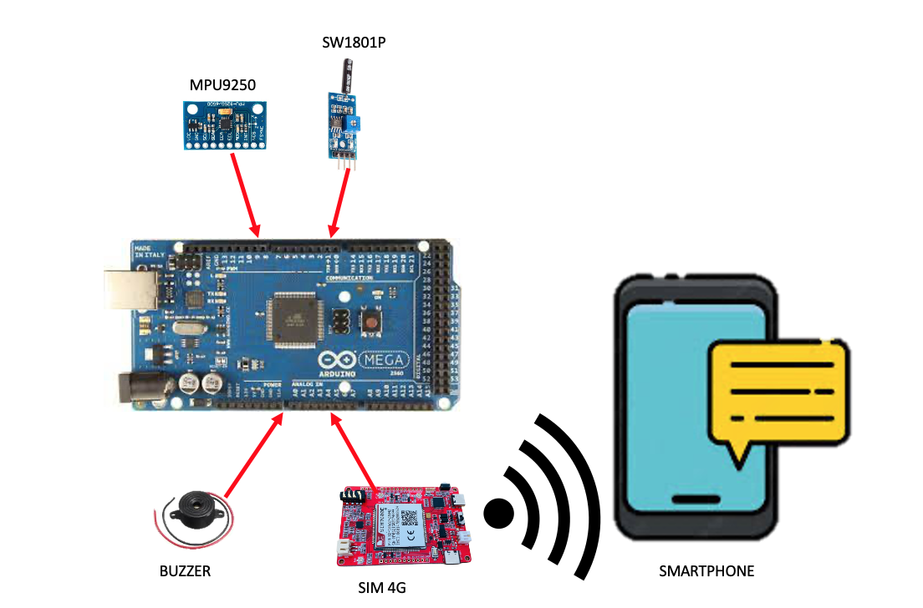

Graphic 5. Wiring diagram of fall detection system.

In this section, the author has utilized a vibration sensor in conjunction with an inclination sensor to establish two conditions for comparison. Each time the value from the SW1801P (vibration sensor) is less than or equal to 100 and the value from the MPU9250 (inclination sensor) indicates a tilt angle beyond the defined threshold, the microcontroller will send a signal to activate both the 4G SIM module and the Buzzer. Upon receiving the fall detection signal, the 4G SIM module will automatically send a warning message to the caregiver or family members of the user. Simultaneously, the alarm will emit a warning sound.**RESULTS AND ACHIEVEMENTS**

<https://github.com/vo-hp/Power-Weelchair>

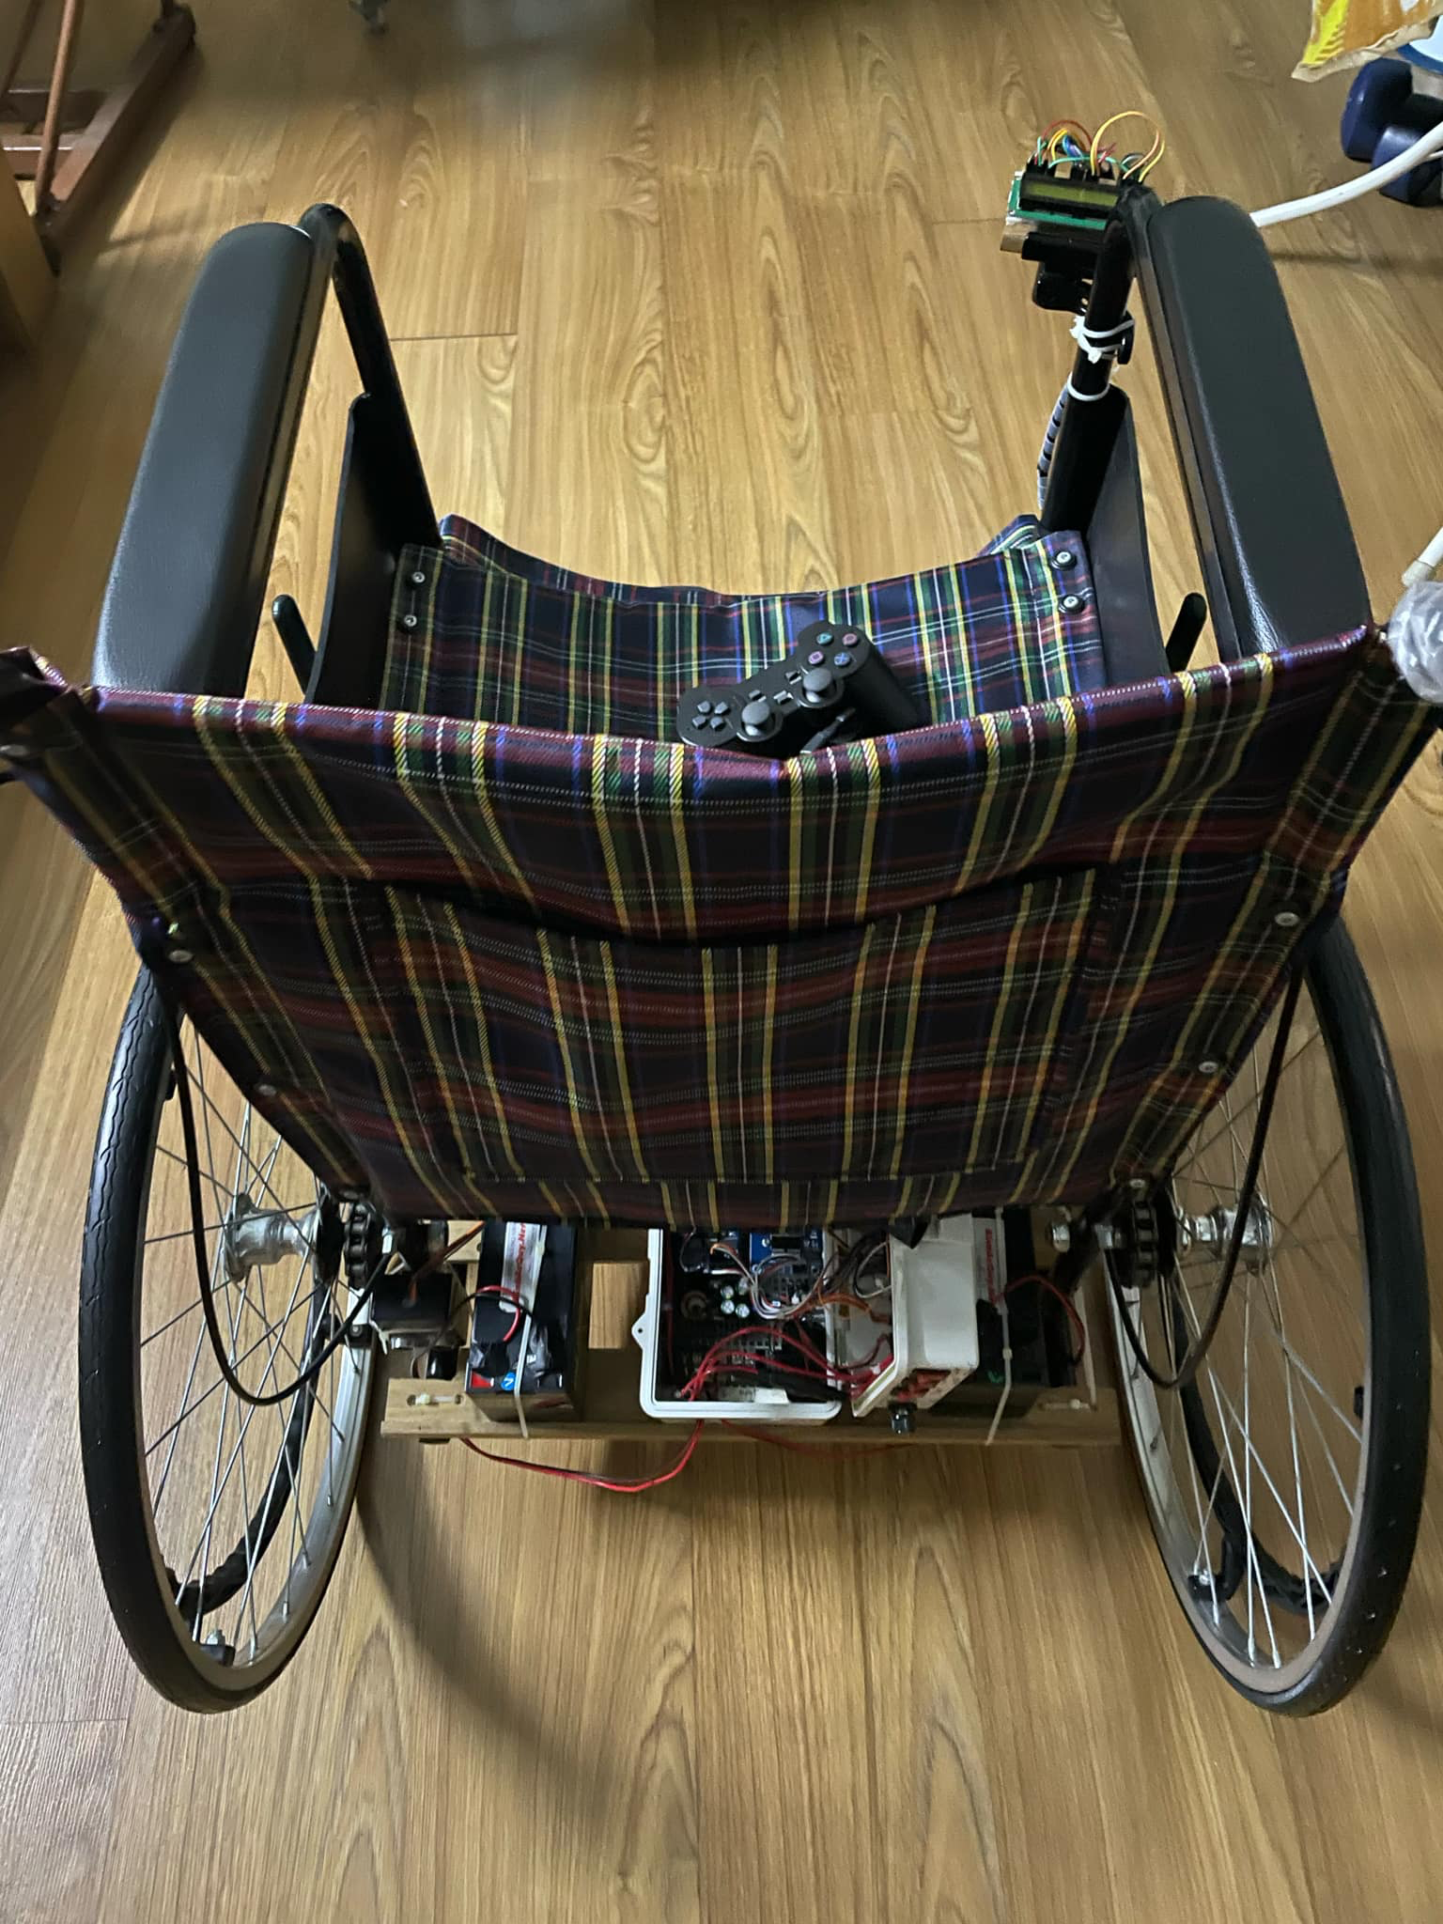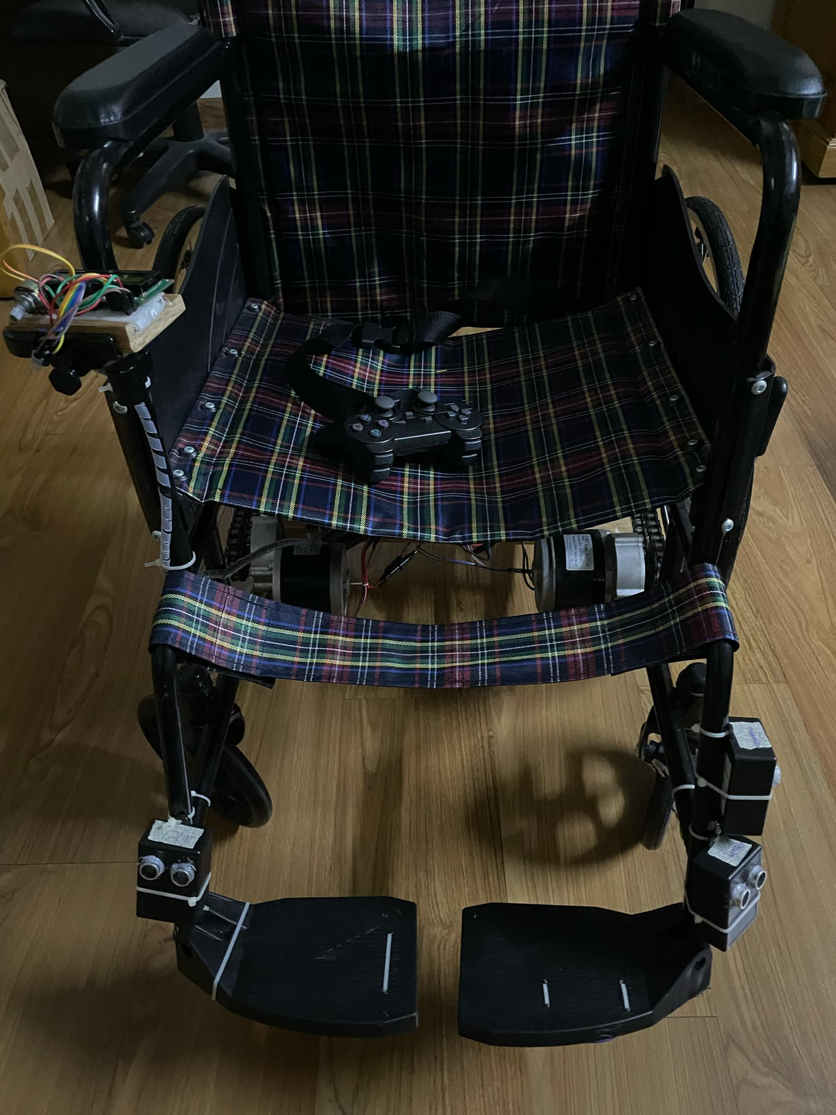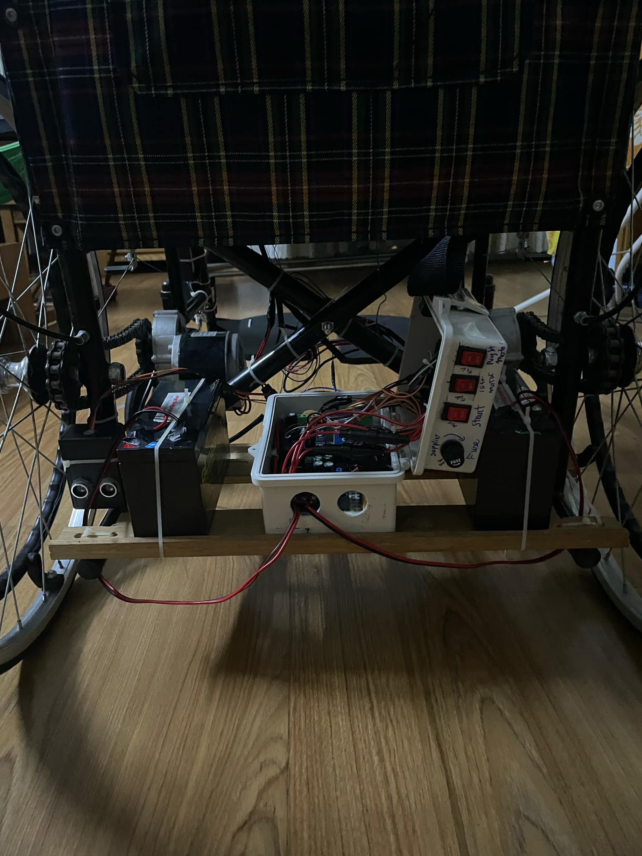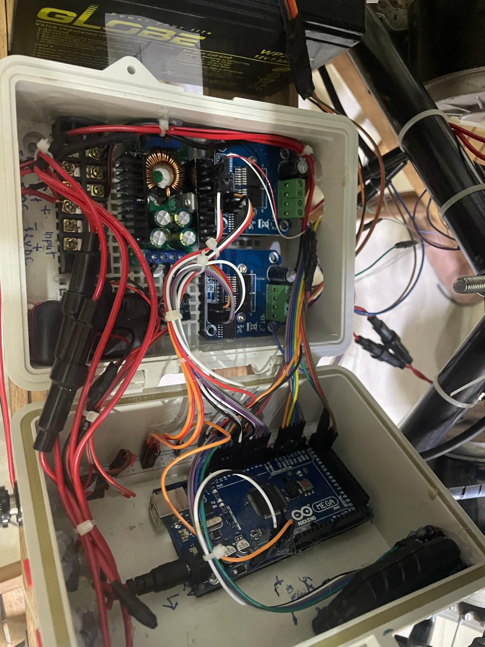

CONCLUSION

The Smart Wheelchair Project is a step towards making mobility more accessible and user-friendly for individuals with physical disabilities. By integrating smart technology such as voice control, obstacle detection, and health monitoring, this project aims to improve the daily lives of users while promoting safety and independence.

|  |  |
| --- | --- |
| Chủ nhiệm đề tài  (Ký và ghi rõ họ tên) | Giảng viên hướng dẫn  (Ký và ghi rõ họ tên) |